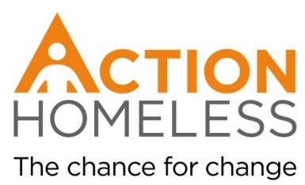
Art Project Volunteer
Purpose of the Role:
We are looking for volunteers to run a series of one-off creative sessions at our community centre, Engage. For you, this role can work in one of two ways:
As a volunteer, you will have the freedom to base a session around a particular skill or hobby that you have. Alternatively, you can facilitate a session based off one of our simple but satisfying plans!
Main tasks and activities:
- Facilitating art sessions for Action Homeless clients
- Supporting clients as they engage with the session
- Chatting to and building relationships with clients
Qualities, experience and skills sought:
You will need to be friendly and pragmatic person. Able to connect with and support clients as they engage in the activity.
- Reliable
- Enthusiastic
- Interest in helping homeless people
- Ability to communicate with and listen to a wide range of people
- Willing to work in a changing environment with vulnerable adults
- Approachable and friendly
- Organised
Training provision – our commitment to you:
We will provide you with a full induction to Action Homeless.
Availability:
Weekday day times, 2 hours per session.
Timing of sessions is flexible around your availability
This role is suitable for those looking for a one off opportunity or longer-term commitment.
Location: Engage, 6 St James Terrace, Leicester, LE2 1NA
Main point of contact:
If you are interested in this role, or have any questions, please contact:
James Riviere (Community Engagement Assistant)
jamesriviere@actionhomeless.org.uk
0116 221 1851

